Assignment 1

1) a) 23.50

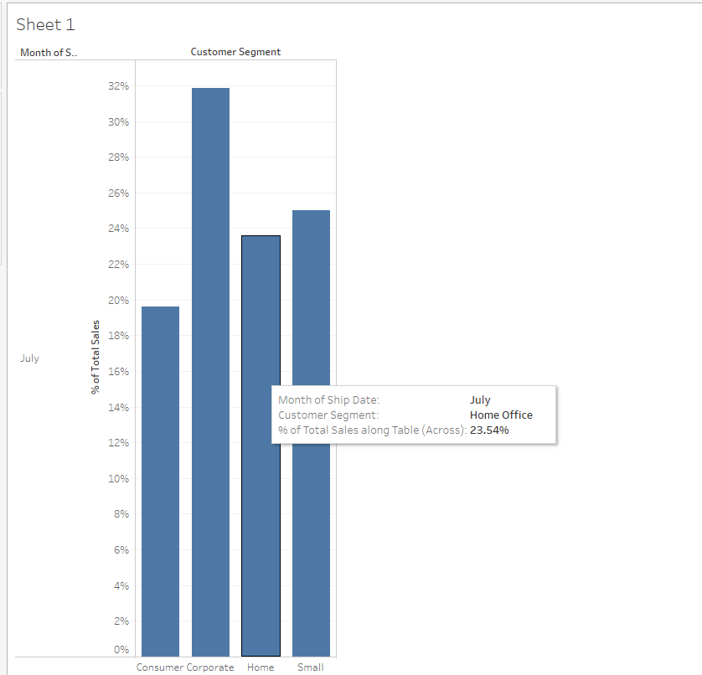

2) c) Sharp AL-1530CS Digital Copier

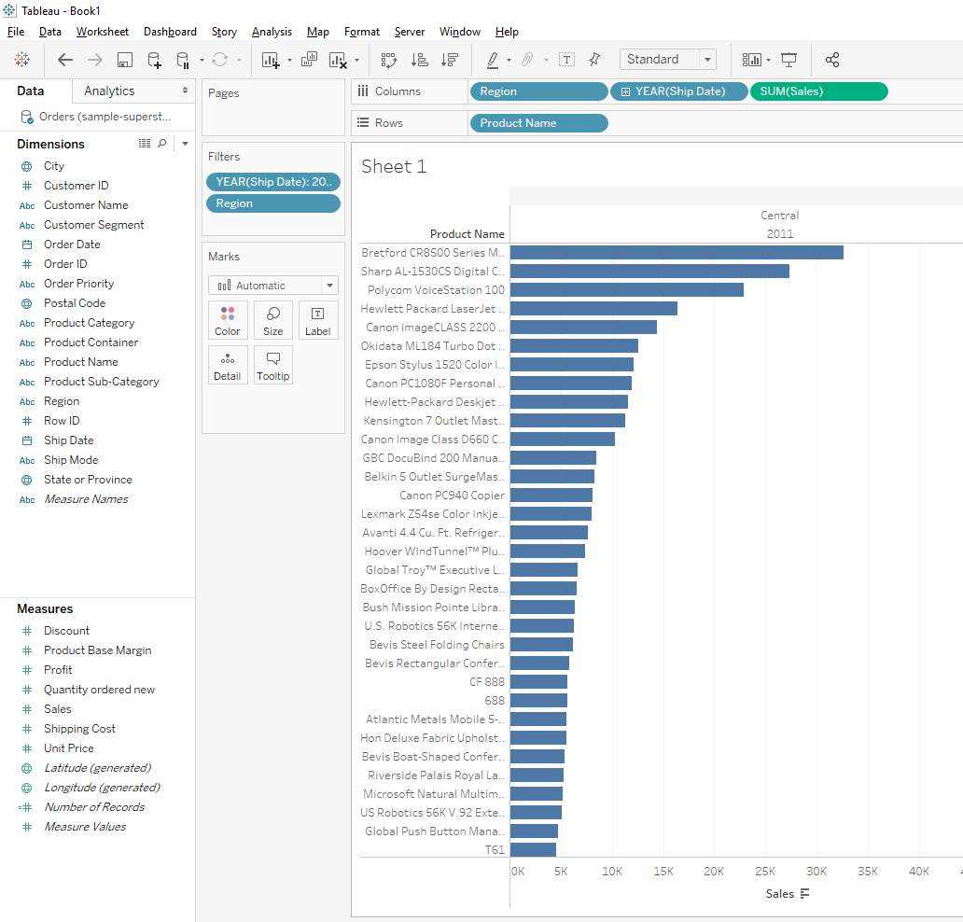

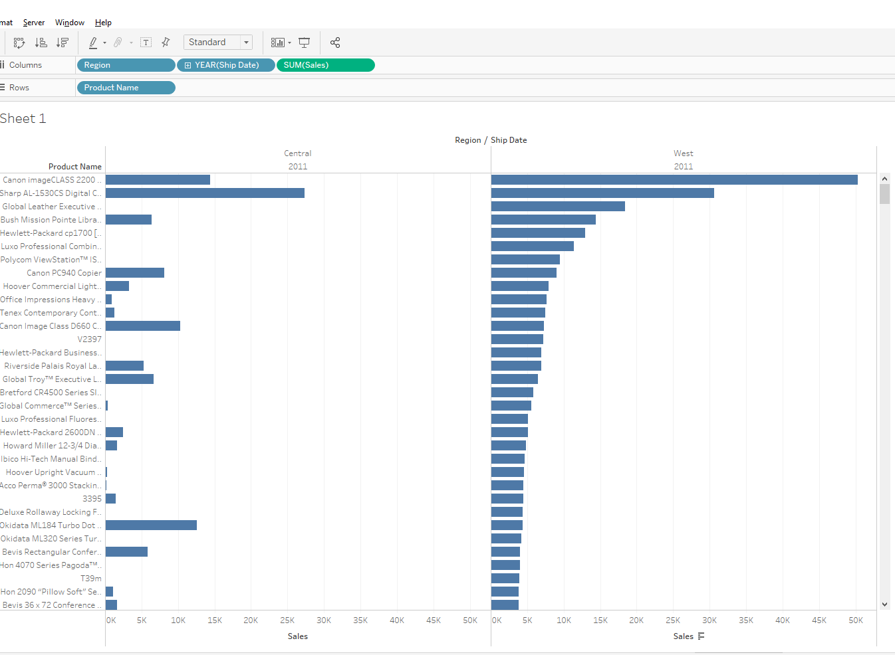

3) a) Colorado

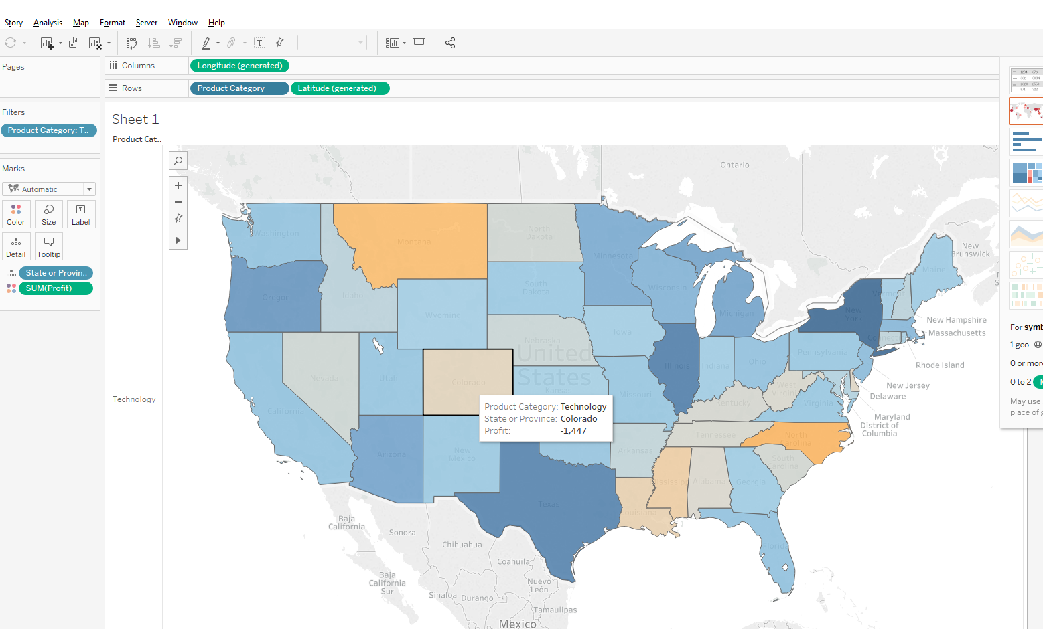

4) b. $816,999

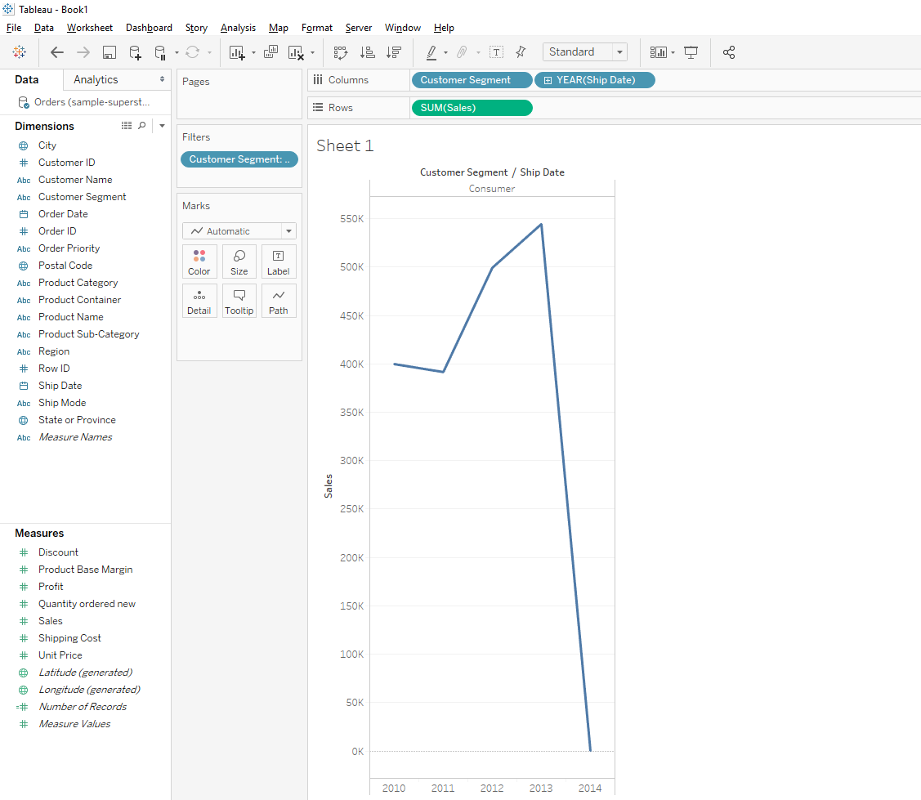

5)

6) d) -771.39

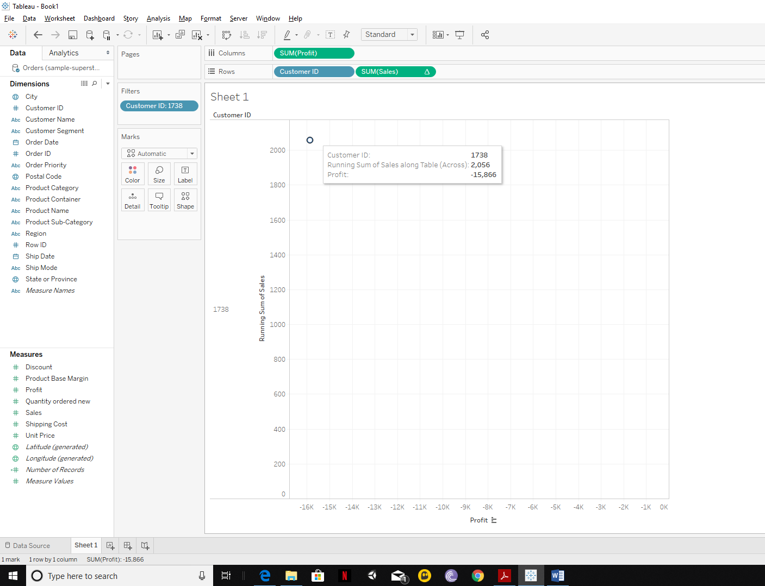

7) a) South Dakota

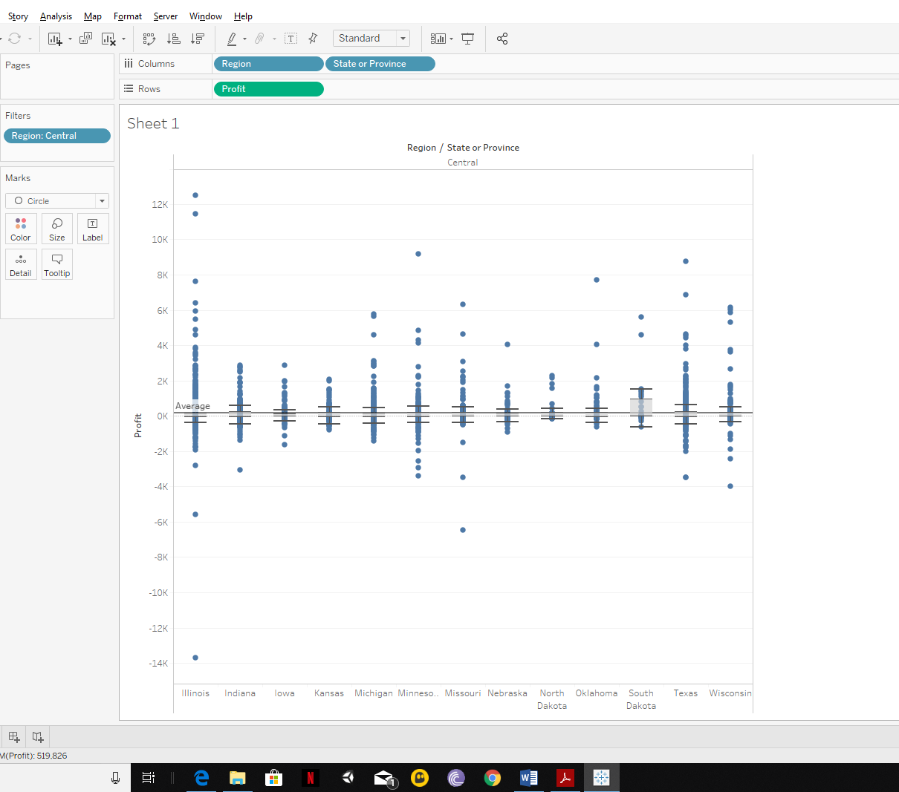

8) b) tables

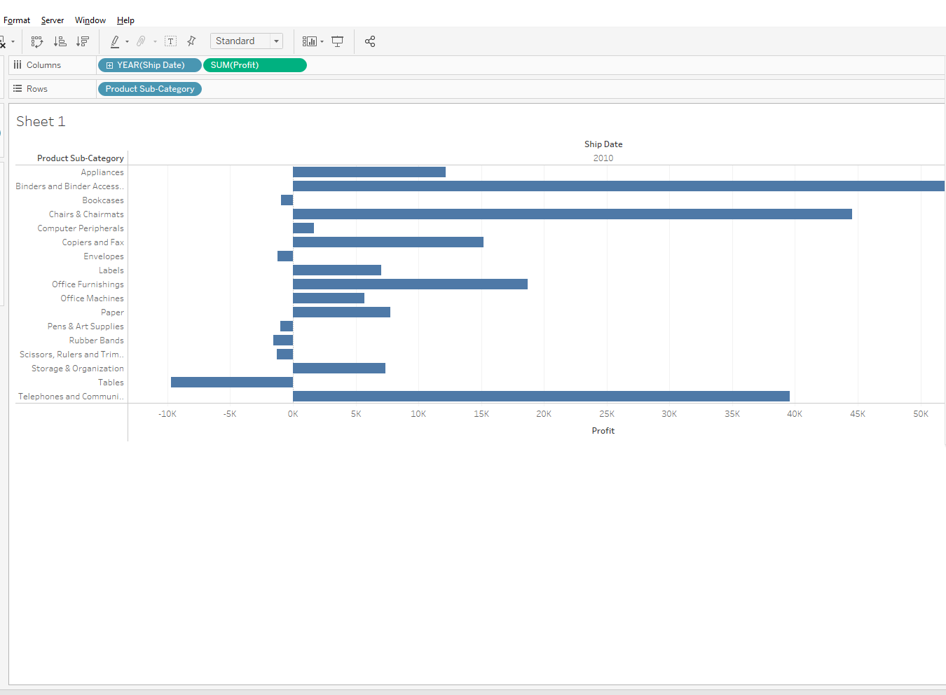

9) d) California

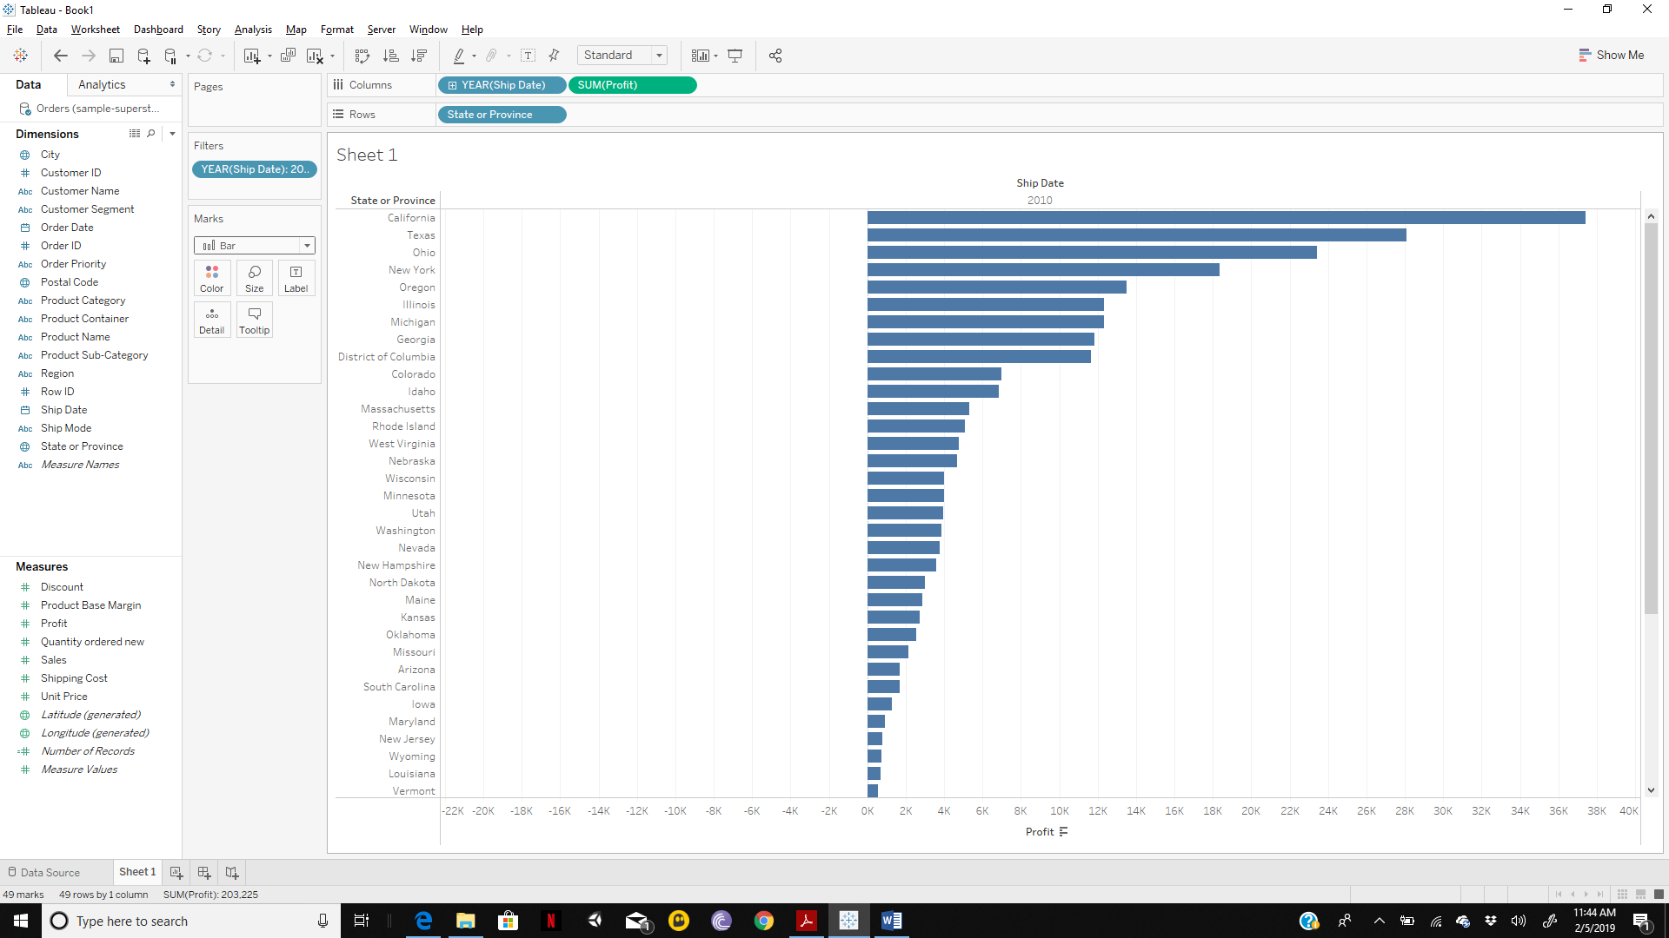

10.1)

We could use various views to compare the sales and profits between regions and states. One view is a stacked bar chart where each bar represents profit and sales for each state (sales represented in Orange, profit represented in Blue). The graph is also split into quadrants based on region(West, Central, East, South) while each state’s bar chart is represented in the quadrant. This graph represents the sales and profit for each state in each region but the graph is cluttered. For a novice user, it would be difficult to make inferences from the graph.

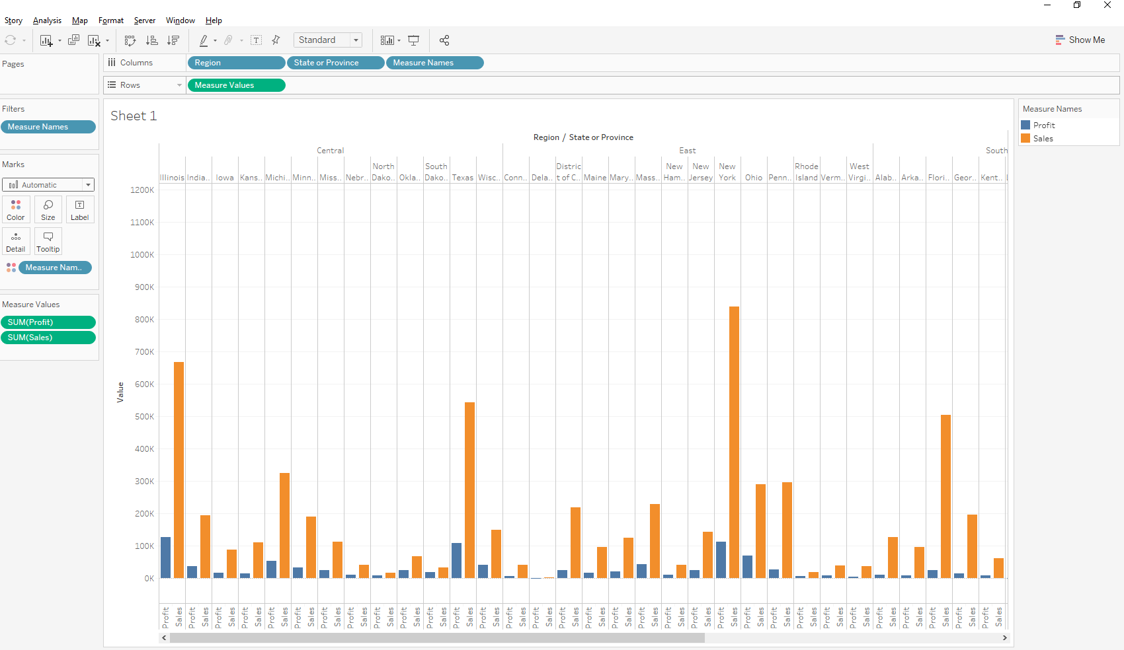

This could be made simpler by using a tree map with filters to represent the required information. We could use labels to identify the state and the region; the color of the block to identify the sum of sales and the size of the block to identify the sum of profit. This would make it very easy for a user to draw comparisons between various states.

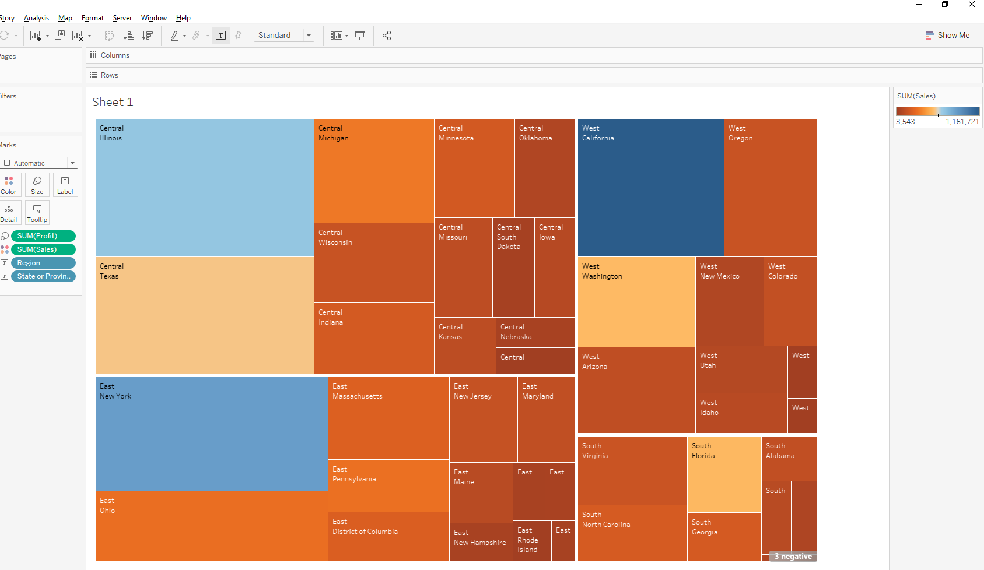

10.2)

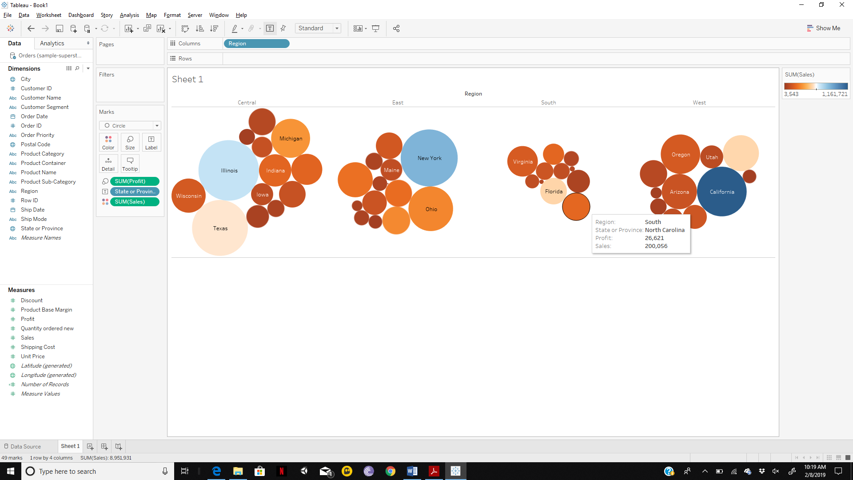

I’ve built an alternate view using packed bubbles to represent the sales and profit of each state in each region. The profit is represented by the size of the bubble while the color represents the sales. Each bubble is labelled by the state name and the graph is split into 4 quadrants based on the region. The reason I built this view is because I thought it was more effective in displaying the contrast between states based on the sales and profit and could also be used to make comparisons between states in the same region and states from different regions.